CS6360.004 Fall 2018

Assignment 3

**Contact Manager**

A listing of the tables and the relationship between them (Database Diagram) as generated by the Management Studio:



In the diagram above, Constraints have been placed on:

**DOB**, **Date_First_Met_On** and **Date_Contact_Added** columns on **Contact** Table

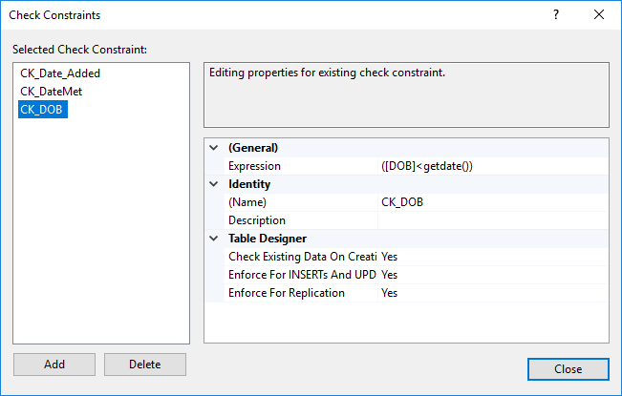

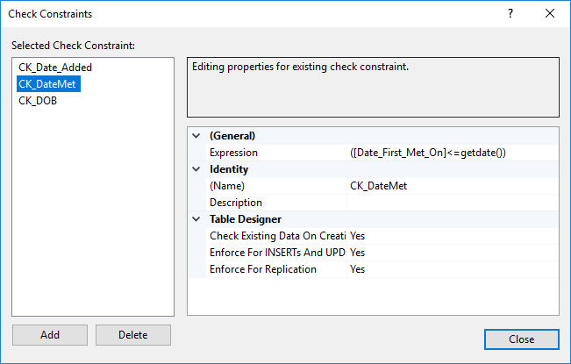

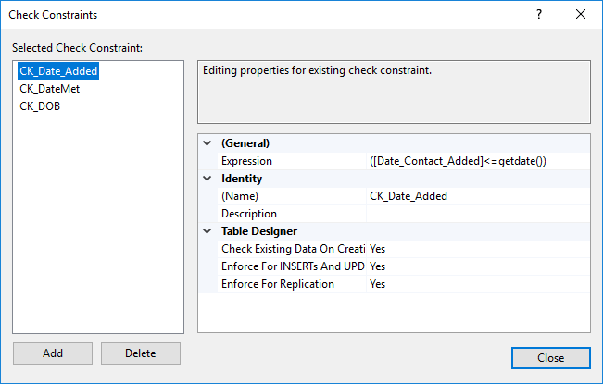

**Date_Next_Call** column on **Phone** Table

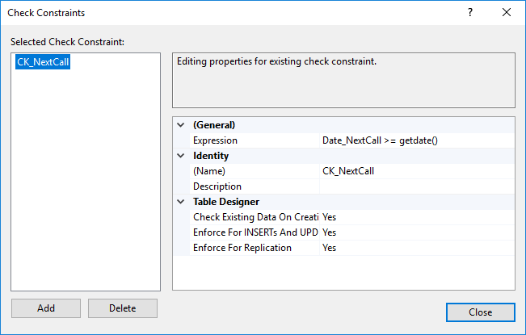

**Call_DateTime** column on **CallHistory** Table.

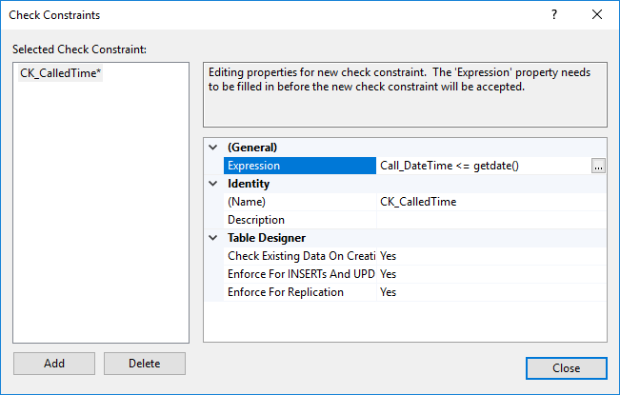Indexes have been placed on the below column as these coulmns are the most searched in the table and are required for joins of the table:

**Call_DateTime** column on **CallHistory** Table

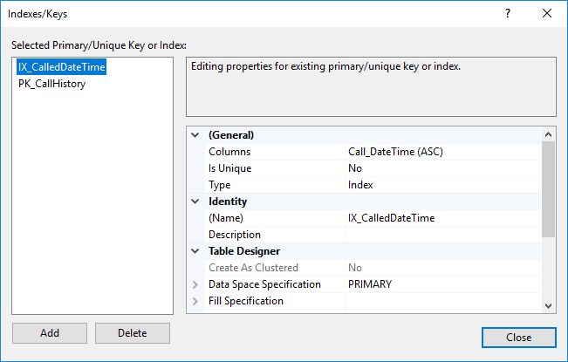

Union of **FirstName, MiddleName** and **LastNam**e on **Contact** table

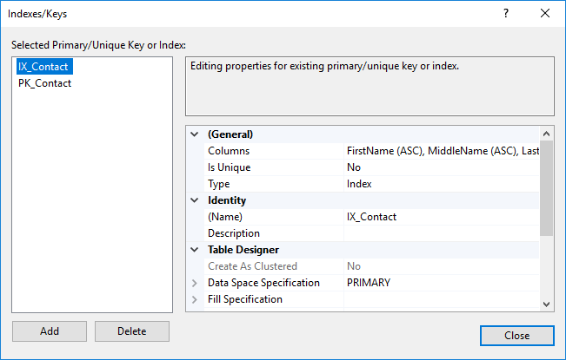

**Date_NextCall** on **Phone** Table

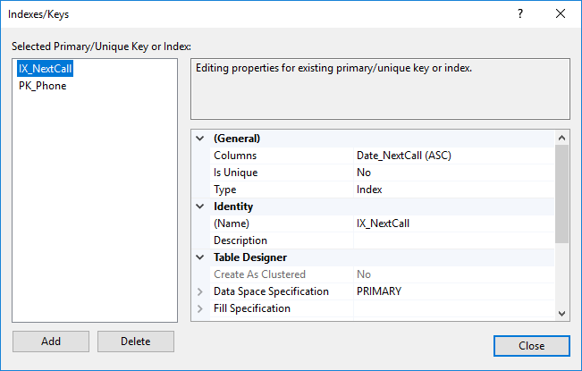

And **ZipCode** on **address** Table

